**StoryTale**

|  |  |
| --- | --- |
| Darshangouda Sangouda Patil  Java Developer | 7847833235 [C:\Users\darsh\Downloads\pngwing.com.png](tel:7847833235)  [darshangouda.s.patil@gmail.com](mailto:darshangouda.s.patil@gmail.com) [https://1000logos.net/wp-content/uploads/2018/05/Gmail_logo_PNG9.png](mailto:darshangouda.s.patil@gmail.com) [www.linkedin.com/in/darshangouda](https://www.linkedin.com/in/darshangouda/) C:\Users\darsh\Downloads\pngwing.com (2).png www.[github.com/darshangouda](https://github.com/darshangouda)/StoryTale [GitHub-Mark-32px](https://github.com/darshangouda) |

**Output:**

**1.Home:**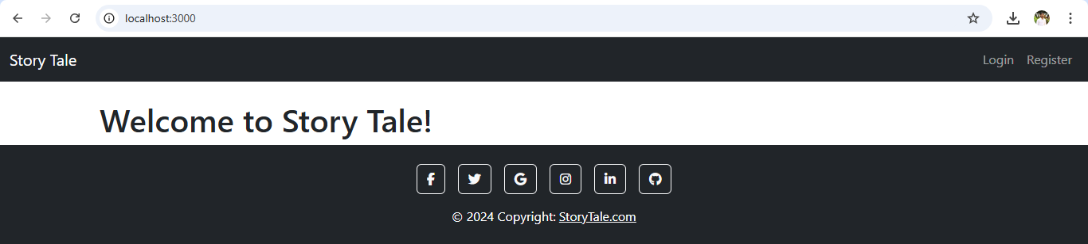

**2. Login:**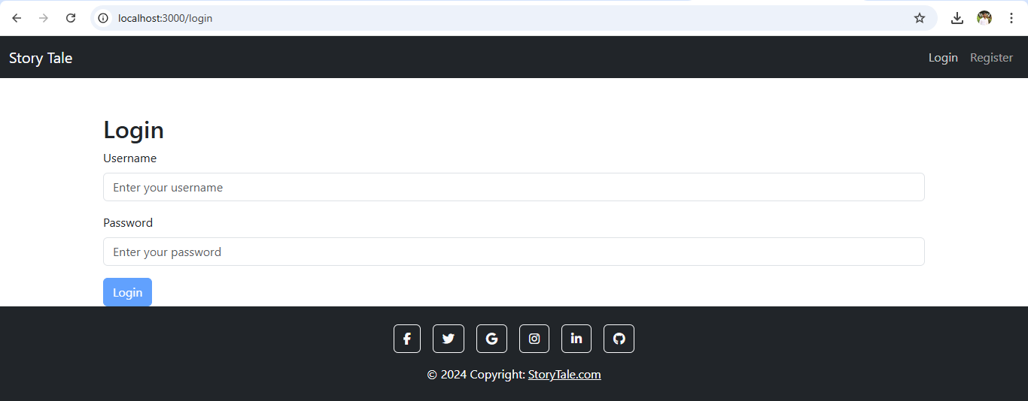

**3. Register:**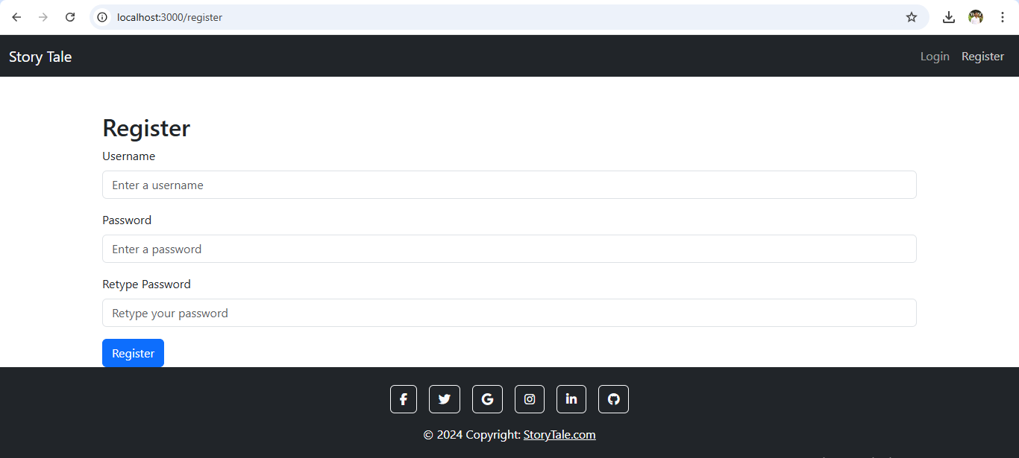

**4. List of Story:  
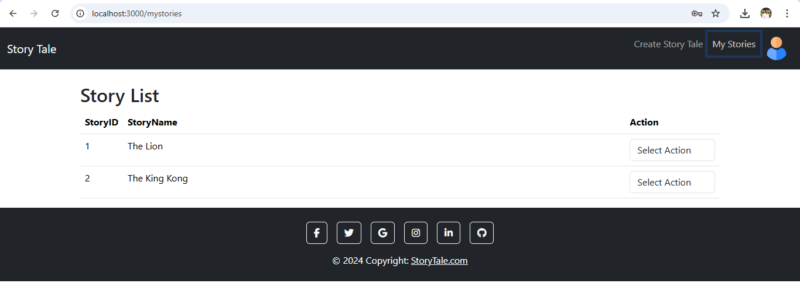**

**5. Create/Update Story:  
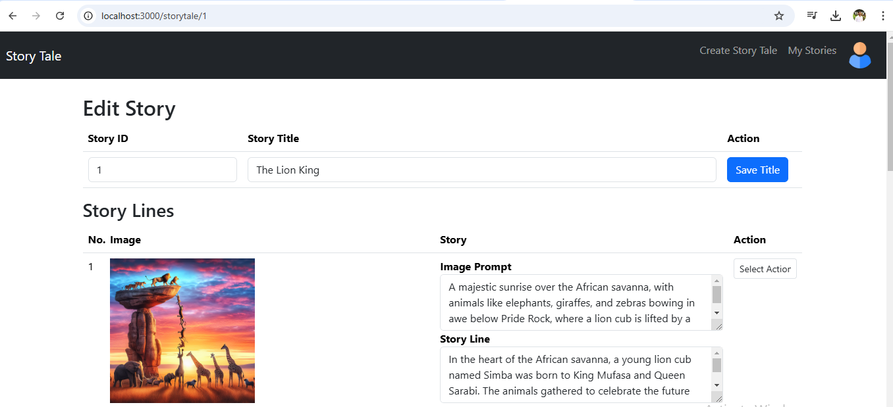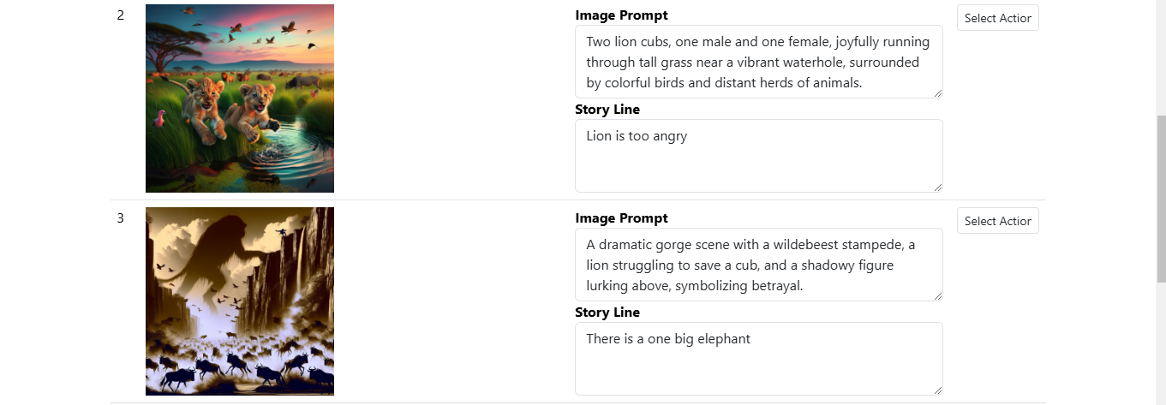**

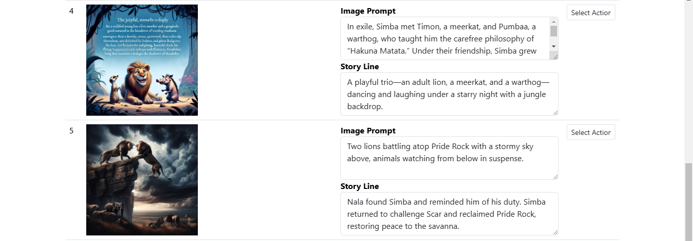

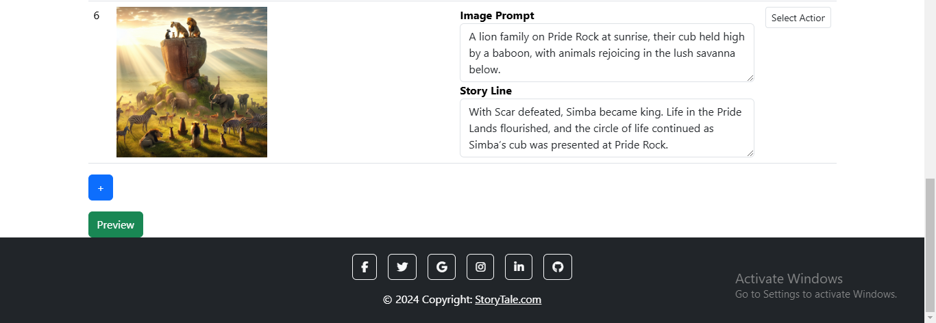

**6.Preview:  
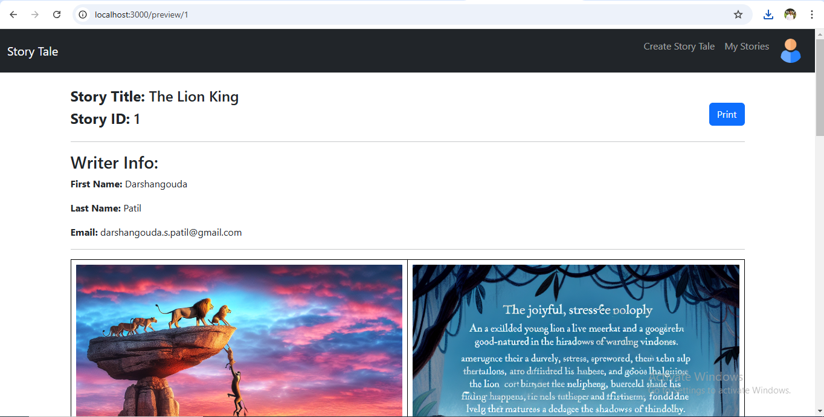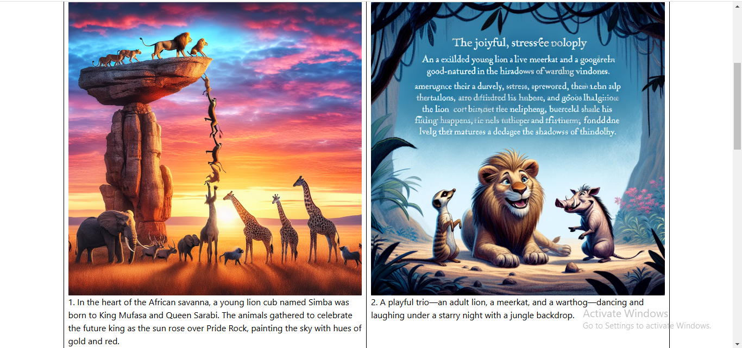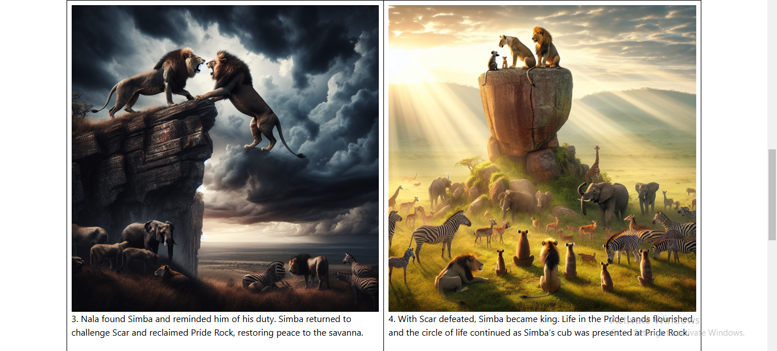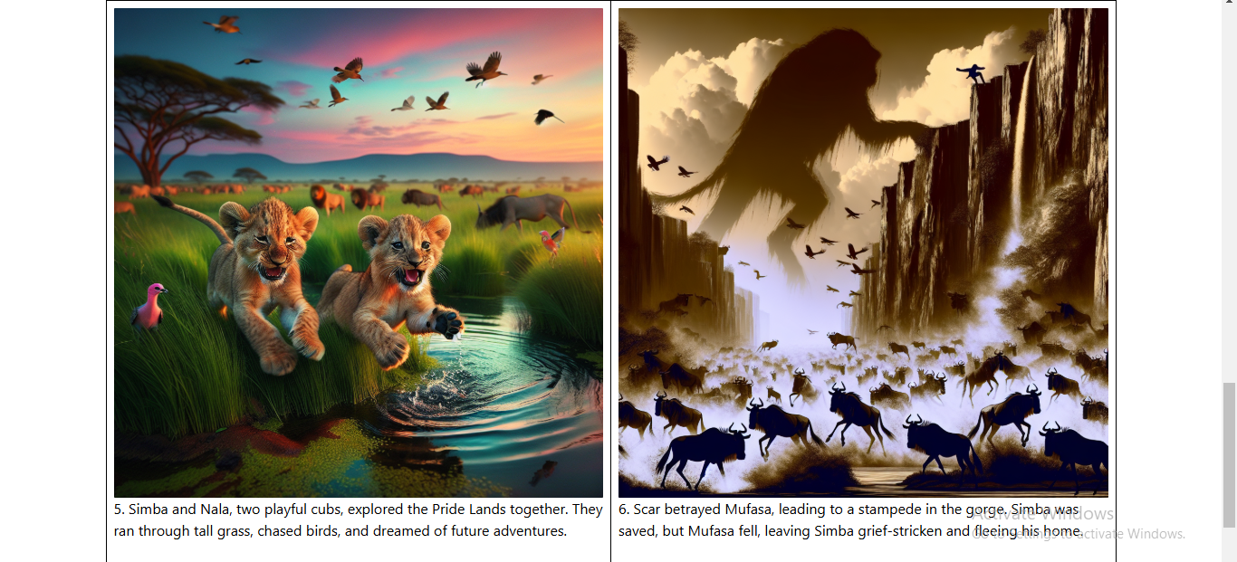**

**7. Edit Writer Info:  
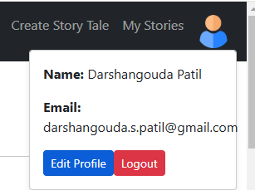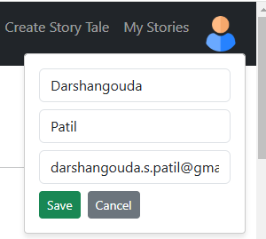**

**8. Logout  
